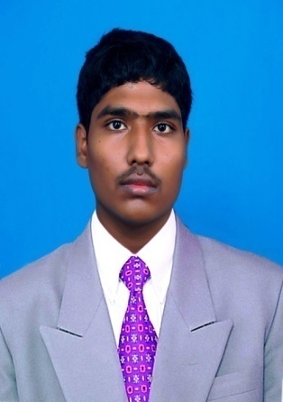

**G.ARUN KUMAR**

**9543315088**

**arunprakasam1994@gmail.com**

**OBJECTIVE**

**I Would like to work in this company, so that will help me to enhance my technical skill**

1. **ACADEMICS**

|  |  |  |  |  |  |
| --- | --- | --- | --- | --- | --- |
| **SR.NO** | **Academic qualification** | **Institution** | **Board/ UNIVERSITY** | **Year of passing** | **percentage** |
| 1. | DIPLOMA IN COMPUTER ENGINEERING | SRI KRISHNA POLYTECHNIC COLLEGE | DOTE | 2014 | 72.8*% |
| 2. | S.S.L.C.(10th) | KALVAIKOTTAI TUTORIAL CENTER | State Board | 2010 | 68% |
| 3. | DIPLOMA IN YOGA FOR HUMAN EXELENCE | ARAKKONAM JOTHI NAGAR MVKM TRUST | Sports university | 2011 | 78.1% |
| 4. | ADVANCE DIPLOMA IN YOGA FOR HUMAN EXLENCE | ARAKKONAM JOTHI NAGAR MVKM TRUST | ALIYAR VISION FOR WISDOM | 2014 | 95.2% |

|  |  |  |  |  |  |
| --- | --- | --- | --- | --- | --- |
| **5** | **BCA** | **MADRAS UNIVERSITY** | **IDE MADRAS UNIVERSITY** | **2016** | **~~47~~** |

1. **COMPUTER PROFICIENCY**

* LANGUAGES :C,C++,JAVA,.NET, HARDWARE AND NETWORKING
* PACKAGES : MS-OFFICE
* PLATFORM USED : Windows 7/8/xp/vista

1. **Academic particular**

To work with a well reputed and establish in a change environment where can use my talents and knowledgment

1. **ACHIEVEMENTS**

* Participated in numerous yoga competition
* Participated in inter-college symposiums.

1. **PROJECT**

* Mail chat using server &client (TCP/UDP).

1. **HOBBIES**

* Listening to music, playing games and surfing Internet

**PERSONAL DETAILS**

|  |  |
| --- | --- |
| **GENDER** | Male |
| **FATHER’S NAME** | S.Gnanaprakasam |
| **MOTHER’S NAME** | G.Krishnaveni |
| **DATE OF BIRTH** | 08/06/1994 |
| **NATIONALITY** | INDIAN |
| **LANGUAGES KNOWN** | English, Tamil (Read, Write & Speak) |
| **Contact Number** | 9543315088 |
| **Contact Address** | No.63 neruji nagar  4th street,3rd cross  Arakkonam-631001  Mobile : 9543315088 |

**DECLARATION**

I hereby declare that all the information mentioned above is true to the best of my knowledge. I will make it my earnest endeavor to discharge competently and carefully the duties you may be pleased to entrust with me.

(Arun kumar.G)